TASK 1(30) Write a paragraph about your groupmate.Follow the instructions:

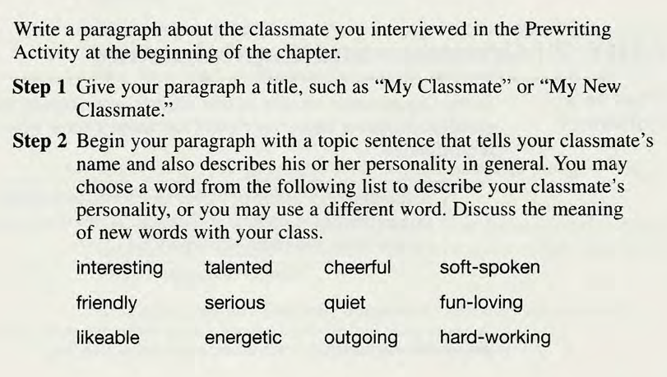

TO BE CONTINUED
